HOMEWORK 1

Student ID: P76087099 Name: Nguyen Vu Le Minh

**Description of your circuit:**

(Please describe the function and dataflow of the circuit.)

1. Description Function

Booth algorithm is a multiplication operation that multiplies two numbers in two’s complement notation. It uses a small of additions and shift operations to do the work of multiplication.

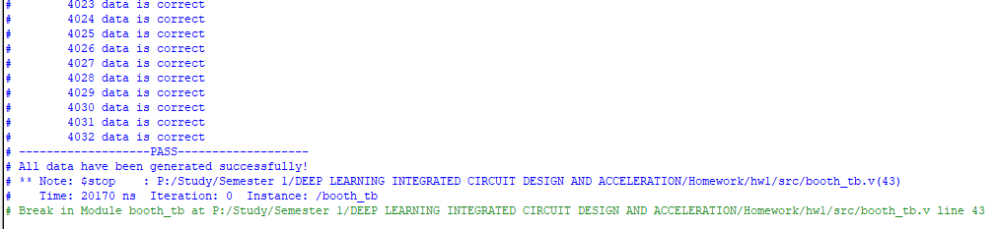

1. Description dataflow of the circuit

Booth Algorithm’s function include 2 inputs and 1 output. The inputs that are multiplicand and multiplier, have 6-bit for each. The output has bit size is 12-bit.

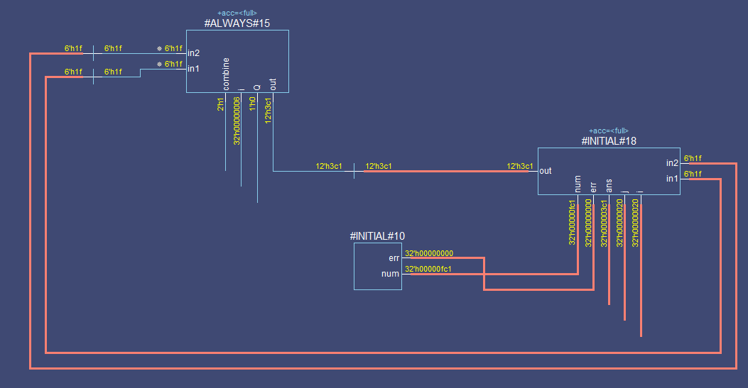

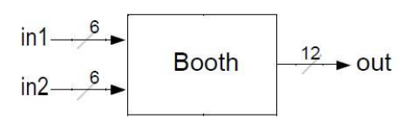

|  |  |  |
| --- | --- | --- |
| Register | Size | Description |
| out | 12 | Output |
| Q | 2 | Initial holds multiplier, ultimately holds low-order n bit of “out” |
| combine | 2 | The combination between the last bit in2 and Q that used for the selection of different executions. |
| in1 | 6 | Multiplicand |
| in2 | 6 | Multiplier |

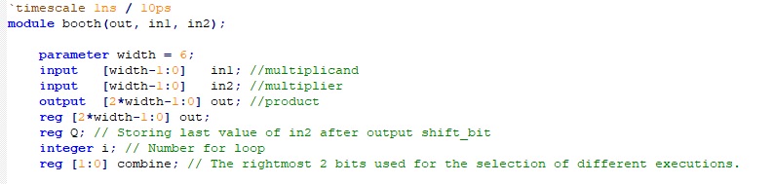

Besides that, we can see that “combine” is a label represent for LSB (least significant bit). Use the LSB (least significant bit) and the previous LSB to determine the arithmetic action. If it is the first pass, use 0 as the previous LSB (1).

|  |  |
| --- | --- |
| LSB | Execution |
| 00 | No execution |
| 01 | Add multiplicand to left half of product. |
| 10 | Subtract multiplicand from left half of product. |
| 11 | No execution |

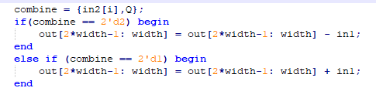

Next step, we perform an arithmetic right shift on the entire product (2).



Finally, we repeat (1) and (2) for 6 times. Because bit_size of multiplier is 6 bit.

**Lesson learn**

(Please write down the experience of completing this assignment, what you learned, and the points of difficulty.)

Before I did this homework, I had to read about booth algorithm to understand what is the calculation in it.

I reviewed some basic knowledge about Verilog, I learned how to use and manage register, how to right shift a variable and add/subtract 2 variables together.

The points of difficult is understand about Booth Algorithm to execute my code.